### 

|  |
| --- |
| Detail Design |
| TEAM 2 – NOT YET |
| Sure-Park Facility Controller |
|  |
|  |

### 

### 

### Revision History

|  |  |  |  |
| --- | --- | --- | --- |
| Version | Date | Description | Author |
| 0.1 | 2016.06.20 | initial | Sangjun Lee |

#### Terms and acronyms

Facility controller : SurePark facility controller program running on Arduino board..

Kiosk: SurePark Kiosk application connected to Facility controller via USB.

#### References

[1] [TEAM2_DOC_03] Architecture Document

### 

### 

### 

### **1. INTRODUCTION**

#### 1.1 SCOPE OF DOCUMENT

This document describes SurePark Facility Controller which is designed by Not Yet Team.

#### 1.2 PURPOSE OF DOCUMENT

The purpose of this document are as below.

* describing how SurePark Facility controller system are structured
* describing how SurePark Facility controller system works.

### **2. STATIC PERSPECTIVE**

Figure 1 shows static view of Facility controller. The main role of each module as follows:

* State manager manages current state and transition of state.
* Command manager manages creating, receiving, sending, and parsing message from MessageQueue.
* Detector manager detects events from sensors and deliver them to State manager.
* Device manager controls Leds, Servo motors. State manager uses this module to control devices.

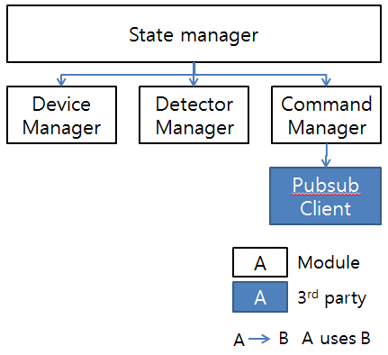

Figure 1. Module view (Static Perspective)

### **3. DYNAMIC PERSPECTIVE**

Figure 2 shows how state changes between states.

* NoServerState is first state facility enters in because server connection is not made. After Command manager make a connection to server, state is changed to Waiting state.
* Waiting state just waits external events - car approaching and car leaving. If events detected, state is changed.
* Parking state is entered if car is detected at entry gate. After reservation is confirmed from server and car parking is detected in slot then state changes to Waiting state again.
* Leaving state is changed from Waiting state. If parked car is detected at exit gate then Leaving state is activated. If payment request is confirmed on server and car passes gate, leaving is completed and current state is changed to Waiting state.

### 

Figure 2. State diagram (Dynamic Perspective)

### 

### **4. Interface between Facility controller and Kiosk.**

Facility controller and Kiosk are connected via USB.

Below command can be exchanged between them.

|  |  |  |  |
| --- | --- | --- | --- |
| Format | From | To | Example |
| #${command}##{body}#$   * command : error, control * body : string message | Facility controller | Kiosk | #$error##call dave#$  #$control##activate_kiosk#$ |
| #{topic}##{body}# + ‘\n’ | Kiosk | Facility controller | #receive_book_no##{‘confirmation_no’:1234}# |